**Example Cover Letter**

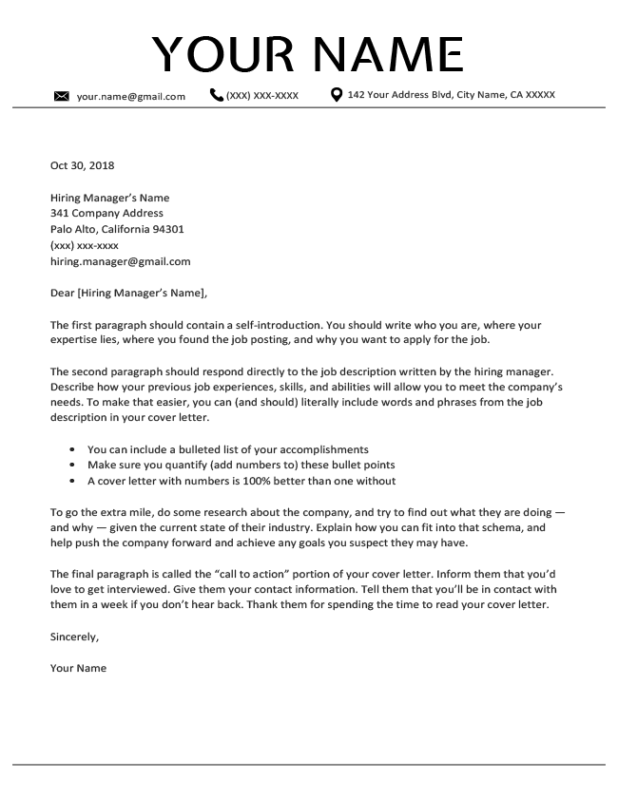

**Example Cover Letter**

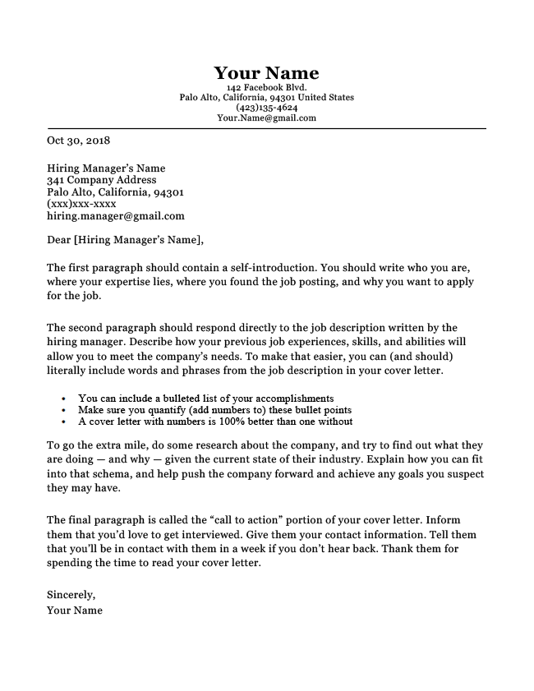

**Agostini Student Sample Cover Letter 2019**

August 2, 2020

University of Arizona Admission

11111 E. 2nd St.

Tucson, Az. 85221

[uofa@uofa.edu](mailto:uofa@uofa.edu)

To Whom It May Concern:

My name is __________, and I am applying to the University of Arizona. I am an extremely responsible student and will work diligently in order to be accepted in the U of A. As an aspiring Basha High Alumi, this college is perfect in helping me achieve my future goals because it offers a neurology program that will give me the best preparation for my field. There is truly no college that I would rather attend than the U of A.

From my academic background and achievements through my high school, I am well prepared for the tasks that lie ahead. I have taken honor and AP classes throughout all of high school in order to learn the most that I could while challenging myself to be best suited for the rigors of college. I was able to achieve all of this while balancing three sports at the same time and achieving a 4.4 GPA. With my ability to be flexible through all the activities that I partake in, I would be a great asset to the U of A.

Outside of school, I have volunteered at Feed My Starving Children, Blood Drives, and during my senior project. I have also joined the school’s Asian club so that I could spread awareness of my own ethics.

I hope that I will further be able to develop my knowledge of neurology at the U of A. Please reach me by my email ________________ or phone __________________ if you have any other questions. Thank you and I look forward to hearing from you soon.

Sincerely,

Your Name